***AURA RETRO SILVER DESIGN:***

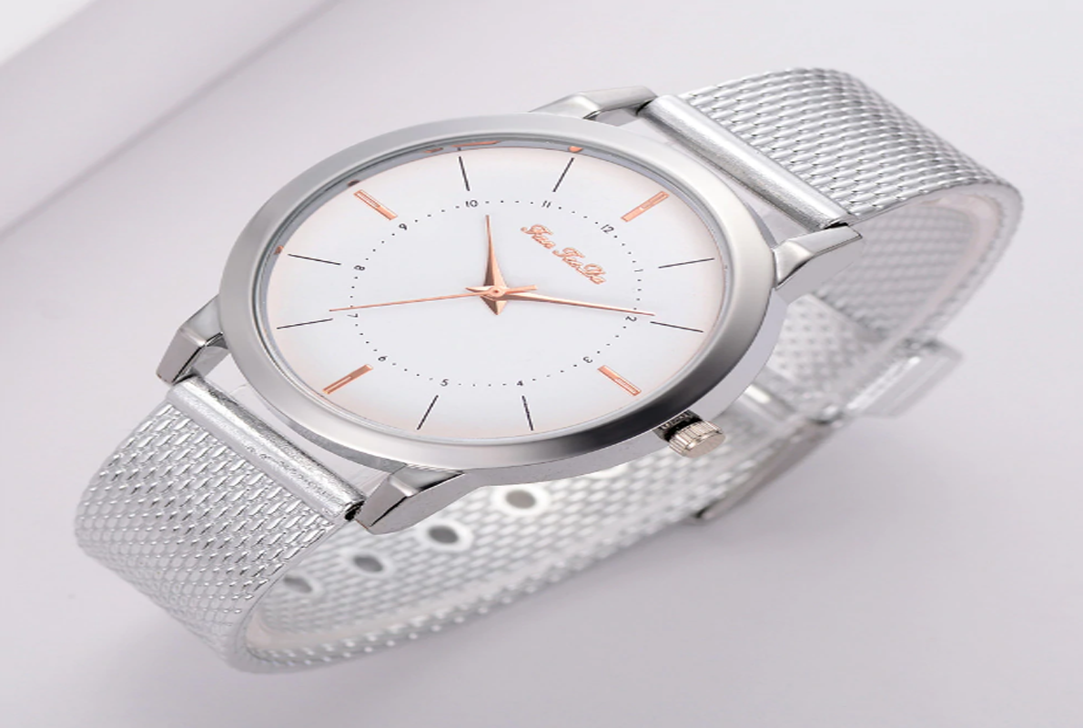

***DETAILS ABOUT THIS WATCH:***

Case Material: Low Lead Brass  
Band Color: Stainless Steel  
Buckle/Clasp: Clasp (Self-Adjust)  
Case Color: Silver-Tone  
Case Finish: Polished  
Case Shape: Oval  
Case Size: Small Size

**SPACES:**

**DIAL COLOR:**Silver

**CASE SIZE:**24mm

**CASE SHAPE:**Other

**CASE MATERIAL:**Brass

**CASE THICKNESS:**6mm

**CRYSTAL TYPE:**Mineral

**MOV'T TYPE:**Quartz

**WATER RESISTANCE:**3 ATM

**STRAP WIDTH:**10mm

**WATER RESISTANCE:**3 ATMS